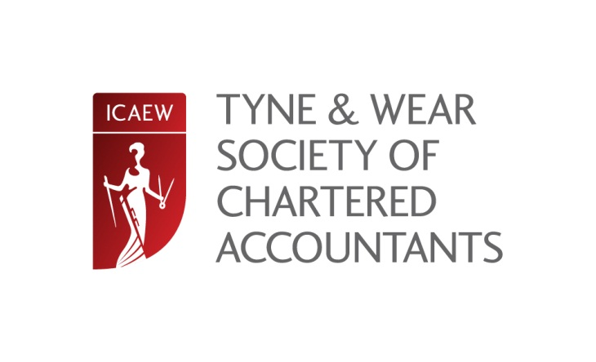

CHARITY general knowledge QUIZ NIGHT
Thursday 11 September 2014, 19:00
Northern Stage, Newcastle

The Tyne and Wear Society of Chartered Accountants proudly presents their annual general knowledge Charity Quiz.

The competition is a fun evening for both members and non-members and is a great chance to showcase your general knowledge!!

Teams are made up of a maximum of four people. Guests are very much welcome, therefore please feel free to bring along a group of your colleagues/friends. The event is a great social and networking evening and the perfect opportunity to meet fellow members and guests.

If you don’t have a team but would like to join one please contact Janine at janine@jirwin.co.uk by 31 August 2104 and we will endeavour to put a team or two together!

PRIZE
The winning team is not only awarded a trophy to mark their triumph on the night, the proceeds of the evening are donated to the winning team’s nominated Charity.

Donations in previous years have been over £500 so let the competition begin!!!!

A raffle draw will also be held on the evening to increase the prize fund. Donations of prizes for the raffle would be much appreciated as always.

Credit/Debit Card Booking Tel 01908 248159
Online Booking - £15.00 inc VAT per person or £60 per team of 4
Postal Booking by cheque - £15.00 inc VAT, or £60 per team of 4
Places can be reserved online at www.icaew.com/northern or by completing the form below - for further information contact Joanne Lucking on 0191 300 0532 joanne.lucking@icaew.com

Name: |  |  | Organisation:
Job position: |  |  | Tel:
Email: |  |  | Tel:
Address: |  |  | Postcode:

