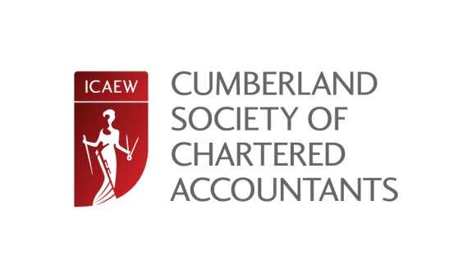
CUMBERLAND SOCIETY OF CHARTERED ACCOUNTANTS ANNUAL DINNER 2015
FRIDAY 13TH MARCH 2015 - ROUNDTHORN COUNTRY HOUSE HOTEL

The Cumberland Society of Chartered Accountants is delighted to invite you to their Annual Dinner to be held on Friday 13th March 2015 at The Roundthorn Country House Hotel, Penrith at 7pm for a 7.30pm start.

The dinner, which is black tie, will commence with a drinks reception at 7pm attended by a photographer from Carlisle Living Magazine. A three course meal will be served from 7.30pm followed by speeches.

This year’s speakers are the Society Chair Lisa Murchie, ICAEW Deputy President Andrew Radcliffe and our guest comedian Mike Farrell.

The evening will cost £40 (including VAT) per person.
Tables of 8 and 10 will be available along with mixed tables for individual members wishing to attend.

There will be a choice of starters and desserts on the evening but you must pre order your choice of main meal.
Please could you indicate on the booking form if you would like either pan roasted chicken fillet with Cumberland pork and chorizo sausage meat, served on pancetta, sun blushed tomato and lentil bolognaise or roast topside of Cumbrian beef served with Yorkshire pudding, natural gravy and horseradish sauce. A vegetarian option is also available.

We intend to provide free transportation where required, subject to sufficient demand. Should you require transportation please could you indicate on the form below so we can make sufficient arrangements.

If you would like to attend please complete the slip below and send a cheque,
made payable to the Northern Society of Chartered Accountants,
no later than Friday 13th February 2015 to:

CSCA Chairman: Lisa Murchie c/o Dodd and Co, FIFTEEN Rosehill, Montgomery Way, Rosehill Estate, Carlisle, CA1 2RW T; 01228 530913 E:Lisa@doddaccountants.co.uk

The society regrets that there can be no refunds should you cancel after Friday 13th February 2015, should you be unable to attend a substitute is welcome at no extra charge.

Contact Name:
Name of Firm:
Address:
Telephone No:
Email Address:
Total of places required: | Beef: | Chicken: | Vegetarian:
Transport required: | Carlisle: | Whitehaven: | Penrith:
Cheque enclosed for £40.00 per person, made payable to NSCA. Total Enclosed: £……………

