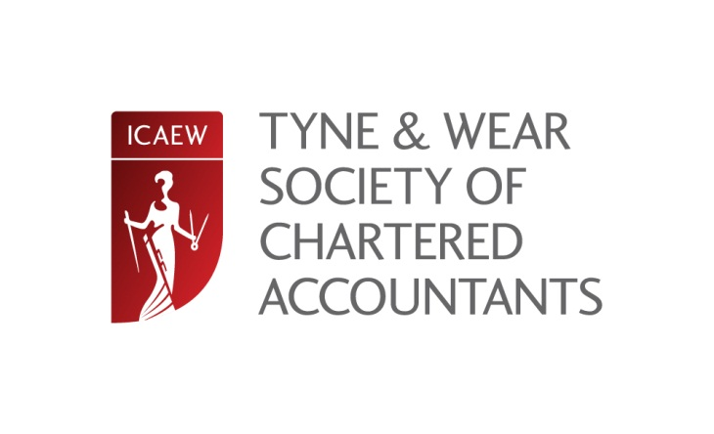

A visit to the Port of Tyne

Thursday 19 June 2014 13.00

Cost: No charge

We are delighted to announce that the Port of Tyne, Company of the Year at The North East Business Awards final last year, has agreed to host a visit and tour on 19th June 2014 at 13:00. Information about the Port of Tyne can be found at www.portoftyne.co.uk/home.

The visit will be hosted by Andy Foster, the Port’s Commercial Manager, and consist of a tour of the Port facilities followed by a question and answer session with a senior member of the Port’s finance team. The session should last no longer than two hours.

The event is free of charge but, due to the nature of the business, numbers are strictly limited and online bookings will therefore be allocated on a first-come-first-served basis. There is no parking at the Port but the nearest metro station, Tyne Dock, is a very short walk away and a 25 minute journey from Monument Station in Newcastle.

The tour will leave the Reception area of Maritime House, Tyne Dock, South Shields, NE34 9PT at 13:00 prompt.

Unless all places have been taken beforehand, the closing date for online bookings is Wednesday 11th June 2014.

To attend: Please complete the form below and return to Joanne Lucking, ICAEW, PO Box 101, Prudhoe, NE42 9AQ or complete the online form at icaew.com/northern

Name: |  |  | Organisation:
Job position: |  |  | Tel:
Email: |  |  | Tel:
Address: |  |  | Postcode:

