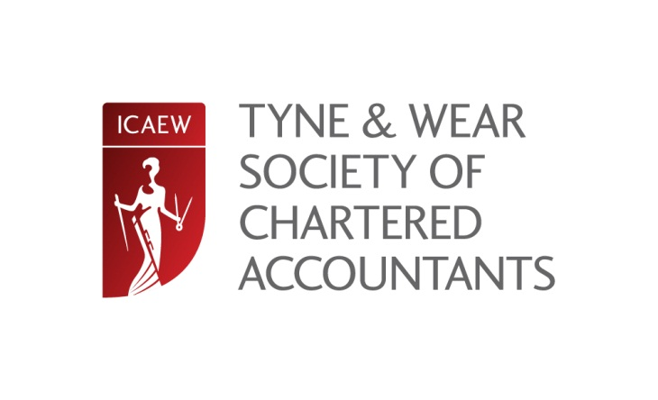

Big Lamp Brewery visit
Grange Rd, Newburn, Newcastle upon Tyne, Tyne and Wear, NE15 8NL

Friday 3 October 19.30 (finish 20:30 approx.)

Plato is acknowledged as saying “He was a wise man who invented beer”. To test that quote, the Tyne and Wear Society is hosting a brewery tour with accompanying refreshments on 3 October 2014 starting at 19:30.

The Big Lamp Brewery in Newburn, Newcastle is the oldest microbrewery in the North East and has won several awards for its ales.

Numbers are strictly limited to 30 people – members and non-members – which will allow two groups of 15 people a tour of the brewery, returning to the Keelman pub next door for a buffet upstairs in our own area…with a private bar. This allows us sampling opportunities of three of four different beers and, because they will be available on draft, a further opportunity to be a barman exists. Half pint glasses will be provided to allow you to pull your own. In the likely event that the casks are emptied, a pay bar exists downstairs.

For directions, you should go to http://biglampbrewers.co.uk/contact/ where you can also see the brewery’s history together with details of its range of ales.

Please note that the closing date for bookings is 12 September 2014. When booking, please ensure you inform of any dietary requirements.

Credit/Debit Card Booking Tel 01908 248159
Online Booking - £15.00 inc VAT, Retired/not employed £15.00 inc VAT
Postal Booking by cheque - £17.50 inc VAT, Retired/not employed £17.50 inc VAT
Places can be reserved online at www.icaew.com/northern or by completing the form below - for further information contact Joanne Lucking on 0191 300 0532 joanne.lucking@icaew.com

Name: |  |  | Organisation:
Job position: |  |  | Tel:
Email: |  |  | Tel:
Address: |  |  | Postcode:

