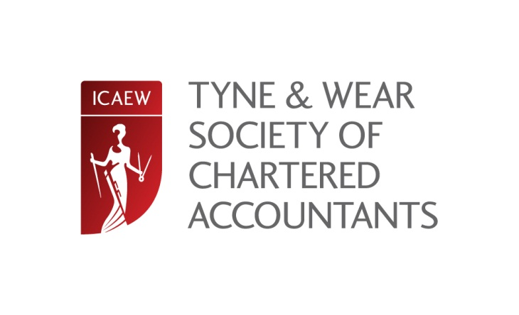

REDWORTH 2015
Friday 27 February – Sunday 1 March 2015
13:00 – 12:30hrs
Redworth Hall Hotel, Redworth, County Durham DL5 6NL

In 2015 the Tyne & Wear General Practitioners’ Conference will be celebrating 21 years at Redworth Hall. We hope that regular attendees, as well as those joining us for the first time, will help up celebrate this milestone.
As usual our speakers will provide up to the minute lectures on the changes affecting the profession as well as tackling topics that are problematic to practitioners.
Our speakers are drawn from all areas – geographically as well as topically – and have a wealth of experience to share. We look forward to welcoming you to another excellent conference.
Confirmed speakers are:
Rebecca Benneyworth | Karen Barwick – Laurus Associates Ltd
Carl Bayley – Bayley Miller Ltd | Ben Huston – Sage (UK) Ltd
Bill Telford – Telford Financial Training Ltd | Joanne Butler - CABA
Topics will include:
Taxation Updates (Income & Capital Taxes) | QAD - What the Reviewers find
Topical Accounting and Auditing | Auto-Enrolment
PAYE and National Insurance | Employment Law
VAT | Cloud Accounting
Business Angels | Building Resilience
Following on from the success of last year, Rebecca will be repeating her ‘on request’ session. You can send in requests to Rebecca at Joanne.lucking@icaew.com up to Monday 23 February 2015 or hand in requests on the Friday saying what you would like her to talk about and, on Sunday morning, she’ll deliver your own personalised lecture.

When you book you will only be charged for the conference element, the accommodation charges are paid to the hotel on the weekend itself. We will continue to book the rooms for delegates (and spouses, if required) at our preferential rates.

We have been able to maintain our prices at the 2014 level as follows:
Residential Delegates - £190 +VAT per person
Non-residential delegates - £225+VAT per person

Thanks to support from CABA we are able to offer members who are retired or are on a career break a special £100 reduction in the cost of the conference

Redworth Hall Hotel have also held their charges for the weekend and these will be (including VAT):
Single accommodation: £222
Twin or double (per delegate): £136
Spouse/partner (non-delegate) sharing accommodation £56 per night
(dinner, bed and breakfast)
For further details, check out the website at www.icaew.com/northern.
REDWORTH 2015 ~ BOOKING FORM
 | No. | Standard |  | No. | Early Bird
 | Bookings after  30/11/14 |  |  | Bookings before 30/11/14
Single |  | @£190.00 |  |  | @£170.00 | £
Double/Twin |  | @£190.00 |  |  | @£170.00 | £
Non-residential |  | @£225.00 |  |  | @£205.00 | £
Spouses (per night) |  | @ £56.00 |  |  | @ £56.00 | £
CABA Single |  | @ £90.00 |  |  | @ £90.00 | £
CABA Double/Twin |  | @ £90.00 |  |  | @ £90.00 | £
CABA Non-residential |  | @£125.00 |  |  | @£125.00 | £
Add Vat @ 20% |  |  |  |  |  | £
Total |  |  |  |  |  | £

Attendees | Member no. | Room type
1
2
3
4
5
6
7
8
9
10

For additional delegates – please use a continuation sheet

Firm name:

Address:

Contact email:

Please complete and return applications with cheques to:

Joanne Lucking
Northern Society of Chartered Accountants
P.O. Box 101
Prudhoe
NE42 9AQ

Cheques should be made payable to NSCA

Alternatively, you can book online at www.icaew.com/northern

